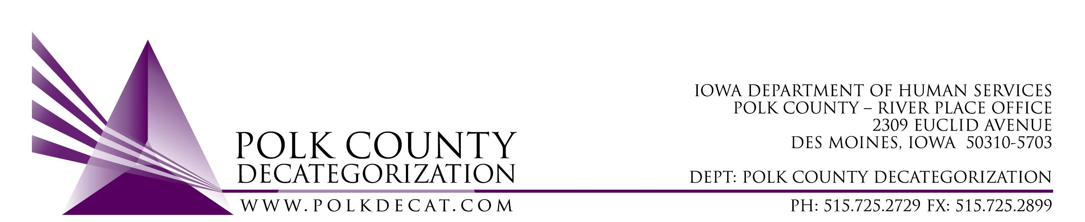

DECAT EXECUTIVE COMMITTEE
Thursday, October 11, 2018
10:00 – 11:30 am
Polk County River Place, Conference Room 3

MEETING A G E N D A

- Call to order: Time _________ | Mike
- Review and approval of the June 14, 2018, August 9, 2018, and the September 13, 2018, meeting minutes*  1st_________ 2nd __________ Approve: Y/N | All
- FY19 Budget review | Teresa
- Discussion only: Add $8,732.00 of unencumbered MYFI funds to DCAT5-17-052, the RJCE contract, to cover increase in activity in the Student Mentoring Project. | Teresa
- Discussion and vote: Possible change of use of FY17 Decat unencumbered funds.* (Tabled from September 13, 2018 meeting)  1st_________ 2nd __________ Approve: Y/N  Other details: ________________________________ | All
- Discussion only: Switch $15,000.00 of DHS MYFI funds from DCAT5-17-120 (Student Support Services – DMPS) contract into the DCAT5-19-001 (Fiscal Agent Services) contract for the purpose of providing incentives and youth/family supports. Vote in November. | All
- Discussion and vote: Modify DCAT5-16-002, Re-entry & Transitioning Youth Services contract, Scope of Work Deliverable 1.3.1.6.c, to change link for statewide FTDM/YTDM standards to https://www.iatrainingsource.org/ftdm-ytdm-documents *  1st_________ 2nd __________ Approve: Y/N | All
- Status of Polk County funds for DCAT5-19-002, Psychological Evaluations | Betty & Teresa
- Decat Updates:  - RJCE Updates  - Decat/CPPC Updates | Teresa
- Next meeting:  - November – vote on FY18 Decat Annual Progress Report  - Anything else? | All
- Adjourn: Time ___________  1st_________ 2nd __________ Approve: Y/N | Mike

Next meeting: November 8, 2018, 10:00 am, Polk County River Place, Conference Room 3

