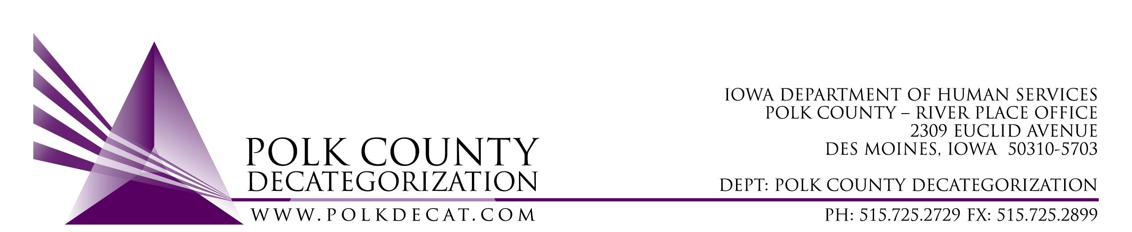

POLK DECAT EXECUTIVE COMMITTEE
Thursday, October 10, 2019
10:00 – 11:30 am
Polk County River Place, Conference Room 3

MEETING A G E N D A

- Call to order: Time _________ | Betty
- Review and approval of the September 12, 2019, meeting minutes *  1st_________ 2nd __________ Approve: Y/N | All
- Introduction of new Decat Administrative & Resource Assistant, Veronica Russell. | Teresa
- Review FY20 budget | All
- Discussion and vote: Accept transfer of funds letter from JCS, 2nd Chief Designation.*  1st_________ 2nd __________ Approve: Y/N | Teresa & Chad
- Discussion and vote: RFP for contracts for services related to youth diversion, education & employment engagement, skill-building and/or community service learning.*  1st_________ 2nd __________ Approve: Y/N | Teresa & Chad
- Review of on-site monitoring reports. | All
- Review and discuss: DCAT5-15-007, Refugee Immigrant Guide contract ending on June 30, 2020 and thoughts on re-procurement. Decision for re-procurement in November Board meeting. | All
- Updates:  - DHS/JCS STS and DHS Clinician Grant applications & upcoming training for DHS Supervisors and LSI Technical Assistance  - On-site monitoring of Orchard Place contracts  - RJCE and CPPC activities | Teresa
- Next meeting:  - RFPs  - On-site Monitoring results  - RJCE and CPPC Updates  - Anything else? | All
- Adjourn: Time ___________*  1st_________ 2nd __________ Approve: Y/N | Betty
Next meeting: November 14, 2019, 10:00 am, Polk County River Place, Conference Room 3.

