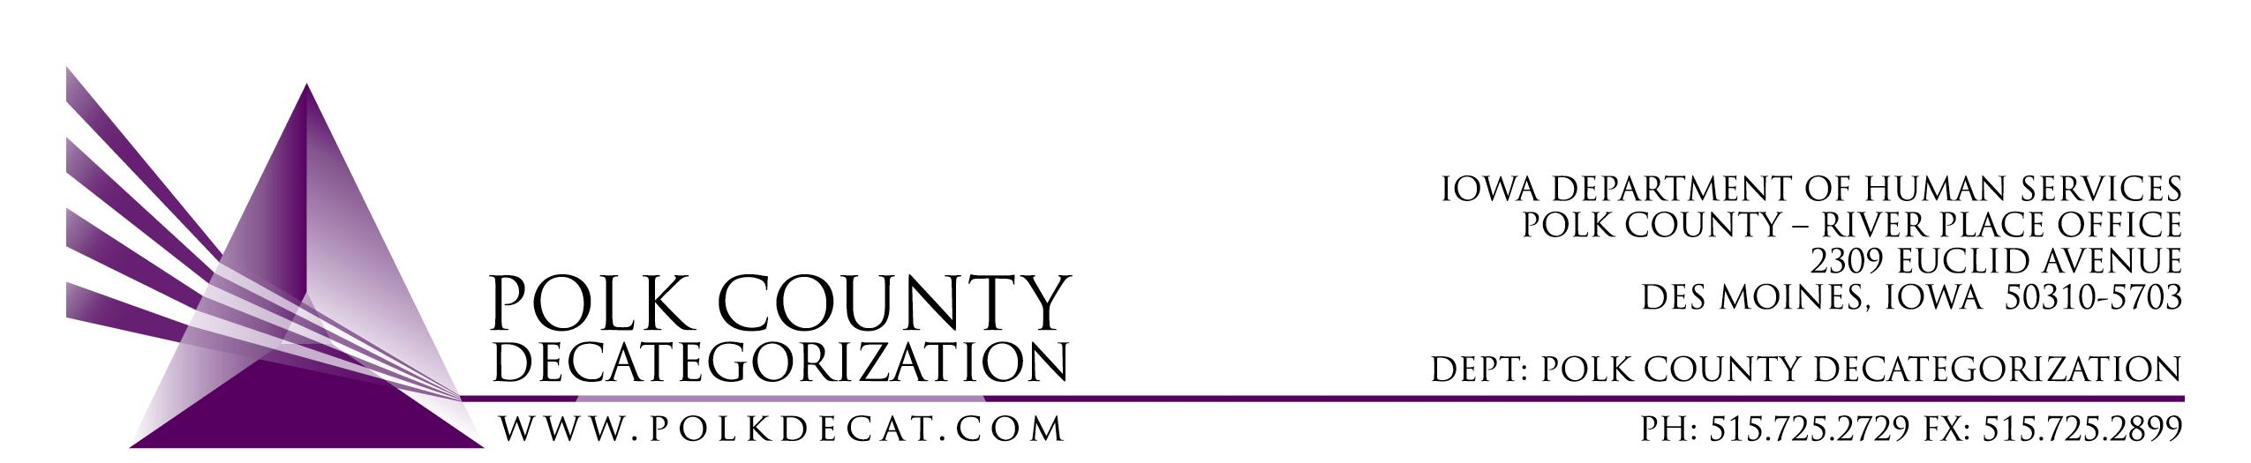

POLK DECAT EXECUTIVE COMMITTEE
Thursday, September 10, 2020
10:00 am – 11:30 pm
Video Conference and/or conference call
1-866-685-1580, pass code 000 999 0270

MEETING A G E N D A

- Call to order: Time _________ | Eric Kool
- Review and approval of the August 13, 2020, meeting minutes *  1st_________ 2nd __________ Approve: Y/N | All
- Discuss and vote: Review and approve FY21 Polk Decat Annual Plan.  1st_________ 2nd __________ Approve: Y/N | All
- Next meeting:  - Transfer(s) of funds, if any  - Possible adjustment to DCAT5-19-001, Fiscal Agent Contract FY21 value  - Review of FY21 budget  - Trauma Informed Supervision project  - RJCE and CPPC activities  - Anything else? | All
- Adjourn: Time ___________*  1st_________ 2nd __________ Approve: Y/N | Eric Kool

Next meeting: September 10, 2020, 10:00 am, via video conference.

