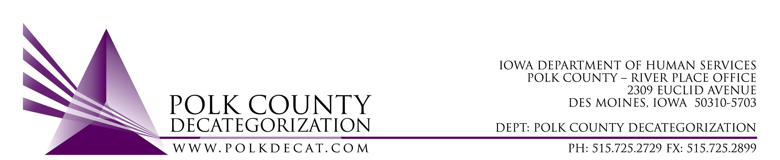

DECAT EXECUTIVE COMMITTEE
Thursday, August 9, 2018
10:00 – 11:30 am
Polk County River Place, Conference Room 3

MEETING A G E N D A

- Call to order: Time _________ | Mike
- Review and approval of June 14, 2018, meeting minutes*  1st_________ 2nd __________ Approve: Y/N | All
- FY19 Budget and FY18 Carry-over review | Teresa
- Discussion and vote: Use FY17 Decat and possibly other unencumbered funds for one-time, short duration contracts, competitively procured, for services related to addressing system disproportionality, youth and/or parent engagement, and trauma/resiliency related services.*  1st_________ 2nd __________ Approve: Y/N  Amount of procurement: $______________________  Other details: ________________________________ | All
- Discussion and vote: Transfer of $35,000.00 in FY17 JCS State Carry-over Funds to CJJP for Functional Family Therapy for families referred by Juvenile Court Services.*  1st_________ 2nd __________ Approve: Y/N | Kelly & All
- Discussion and vote: Review and accept FY18 Polk CPPC Evaluation Year-End Report. (Does not require official vote, but Board approval provides confirmation that it has been reviewed.)  1st_________ 2nd __________ Approve: Y/N | All
- Discussion and vote: Review and approve proposal for CPPC AmeriCorps member for Polk County.*  1st_________ 2nd __________ Approve: Y/N | Jordan Kauffman and all
- Status of Polk County funds for DCAT5-19-002, Psychological Evaluations | Betty & Teresa
- Decat Updates:  - FY18 Quarterly Performance review  - FY19 Decat Annual Service Plan*  - RJCE Activities  - CPPC Activities  - Trauma Informed Services Technical Assistance, JCS and DHS | Teresa
- Next meeting:  - Anything else? | All
- Adjourn: Time ___________  1st_________ 2nd __________ Approve: Y/N | Mike

Next meeting: September 13, 2018, 10:00 am, Polk County River Place, Conference Room 3

