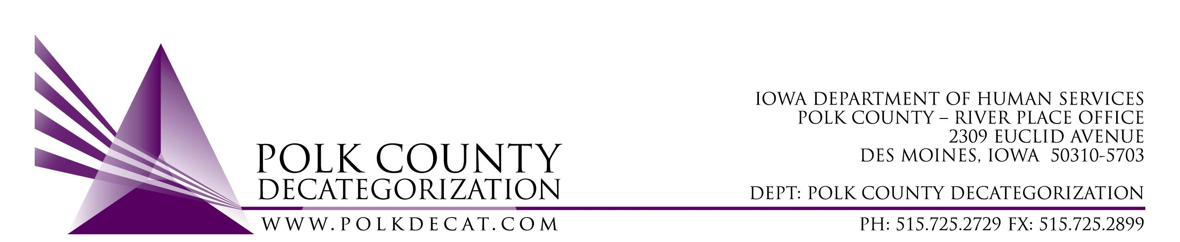

DECAT EXECUTIVE COMMITTEE
Thursday, June 14, 2018
10:00 – 10:15 am
Conference Call: 1-866-685-1580, Pass code – 000 999 0270#

MEETING A G E N D A

- Call to order: Time _________ | Mike
- Review and approval of May 10, 2018, meeting minutes*  1st_________ 2nd __________ Approve: Y/N | All
- Discussion and vote: Accept modification to March 1, 2017, Transfer of Funds from the Des Moines Cluster (Polk County) Decategorization to CJJP.*  1st_________ 2nd __________ Approve: Y/N | Chad & All
- Next meeting:  - Next meeting August 9, 2018?  - Anything else? | All
- Adjourn: Time ___________  1st_________ 2nd __________ Approve: Y/N | Mike

Next meeting: August 9, 2018, 10:00 am, Polk County River Place, Conference Room 3

