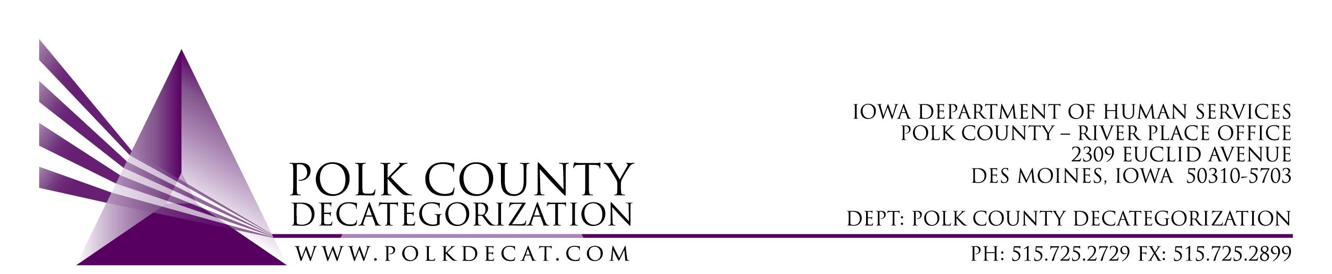

DECAT EXECUTIVE COMMITTEE
Thursday, June 13, 2019
10:00 – 11:30 am
Conference Call: 1-866-685-1580, Pass code: 000 999 0270#

MEETING A G E N D A

- Call to order: Time _________ | Betty
- Review and approval of the May 9, 2019, meeting minutes *  1st_________ 2nd __________ Approve: Y/N | All
- Vote to accept transfer of funds letters, FY19 State dollars totaling $1,179,736.00, from JCS.*  1st_________ 2nd __________ Approve: Y/N | All
- FY19 and FY20 Budget review | Teresa
- Decat Updates: (if there is time)  - RJCE Updates – IDI training, CASP  - Decat/CPPC Updates  - Careportal  - ACEs/Trauma Workgroups and Projects  - Decat team alignment work  - Event Funding Request revamp | Teresa
- Next meeting:  - Do we need to meet in July?  - Careportal  - Contract amendments? | All
- Adjourn: Time ___________*  1st_________ 2nd __________ Approve: Y/N | Betty

Next meeting: July 11, 2019, or August 8, 2019, depending on vote, 10:00 am, Polk County River Place, Conference Room 3.

