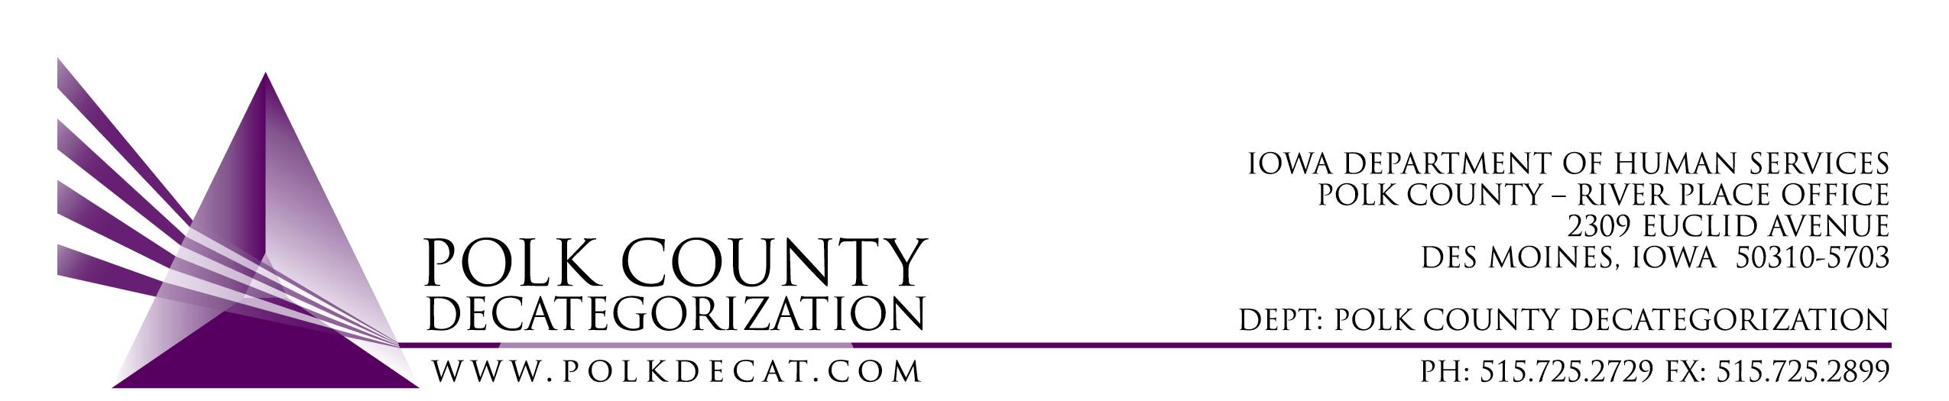

POLK DECAT EXECUTIVE COMMITTEE
Thursday, June 11, 2020
10:00 am – 11:30 pm
Video Conference and/or conference call
1-866-685-1580, pass code 000 999 0270

MEETING A G E N D A

- Call to order: Time _________ | Eric Kool
- Review and approval of the May 14, 2020, meeting minutes *  1st_________ 2nd __________ Approve: Y/N | All
- Review of FY20 budget | Teresa
- Discuss and vote: Accept FY20 Transfer of Funds letters from JCS, totaling $1,078,985.00.*  1st_________ 2nd __________ Approve: Y/N | Teresa
- Updates:  - Trauma Informed Supervision  - Work from home status  - RJCE and CPPC | Teresa
- Next meeting:  - Transfer(s) of funds, if any  - Review of FY20 budgets  - Semi-annual contract performance review  - Trauma Informed Supervision project  - RJCE and CPPC activities  - Anything else? | All
- Discuss and vote: Yes or no to July board meeting if there are no voting items.*  1st_________ 2nd __________ Approve: Y/N | All
- Adjourn: Time ___________*  1st_________ 2nd __________ Approve: Y/N | Eric Kool

Next meeting: July 9, 2020, or August 13, 2020, as voted on by the board, 10:00 am, Polk County River Place, Conference Room 3 or via video conference depending on “stay in place” status.

