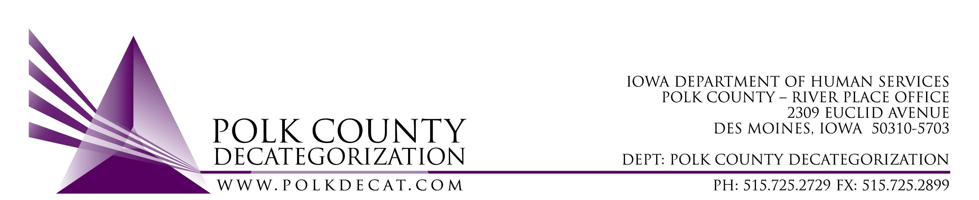

DECAT EXECUTIVE COMMITTEE
Thursday, May 9, 2019
10:00 – 11:30 am
Polk County River Place, Conference Room 3

MEETING A G E N D A

- Call to order: Time _________ | Betty
- Review and approval of the April 11, 2019, meeting minutes and renewal voting addendum, round 2*  1st_________ 2nd __________ Approve: Y/N | All
- FY19 & FY20 Budget review | Teresa
- Discussion and vote: Add $1,500.00 to DCAT5-14-017, Diversion & Mediation contract, Polk County Attorney’s Office, to ensure coverage until the end of the year. Voting on addition of funds as well as Amendment document.*  1st_________ 2nd __________ Approve: Y/N | All
- Discussion and vote: Transfer of FY17 JCS funds to other Decat Clusters in Des Moines Service Area:*  - Creston: Transfer $12,230.00 & Transfer Letter  1st_________ 2nd __________ Approve: Y/N  - Leon: Transfer $20,651.00 & Transfer Letter  1st_________ 2nd __________ Approve: Y/N  - Indianola: Transfer $50,000.00 & Transfer Letter  1st_________ 2nd __________ Approve: Y/N | All
- Discussion and vote: Accept Transfer of Funds letter from DHS.  1st_________ 2nd __________ Approve: Y/N | All
- Discussion and vote: Decat Admin Assistant, Cassie Thomas, go to full-time effective June 1, 2018.*  1st_________ 2nd __________ Approve: Y/N | All
- Discussion and vote: Accept Polk County Community Partnership for Protecting Children (CPPC) FY20 Annual Plan*  1st_________ 2nd __________ Approve: Y/N | All
- Decat Updates: (if there is time)  - RJCE Updates  - Decat/CPPC Updates | Teresa
- Next meeting:  - Do we need to meet in June?  - Anything else? | All
- Adjourn: Time ___________  1st_________ 2nd __________ Approve: Y/N | Betty

Next meeting: June 13, 2019, 10:00 am, Polk County River Place, Conference Room 3, if needed.

