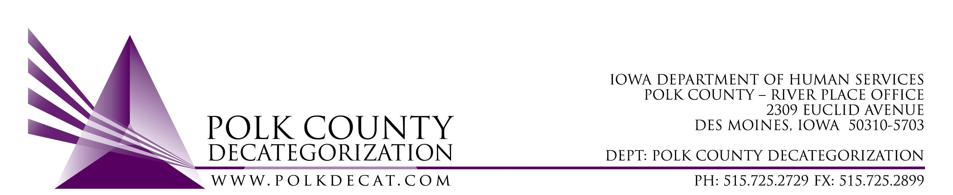

DECAT EXECUTIVE COMMITTEE
Thursday, April 11, 2019
10:00 – 11:55 am
Polk County River Place, Conference Room 3

MEETING A G E N D A

- Call to order: Time _________ | Betty
- Review and approval of the March 14, 2019, meeting minutes and addendum*  1st_________ 2nd __________ Approve: Y/N | All
- FY19 Budget review and revised projection for FY20 | Teresa
- Review & vote: Remaining Decat Contracts & Renewals for FY20*  Refer to Agenda Addendum/Voting Document | All
- Decat Updates: (if there is time)  - RJCE Updates  - Decat/CPPC Updates | Teresa
- Next meeting:  - Discuss and vote on use of JCS funds  - Anything else? | All
- Adjourn: Time ___________  1st_________ 2nd __________ Approve: Y/N | Betty

Next meeting: April 11, 2019, 10:00 am, Polk County River Place, Conference Room 3

