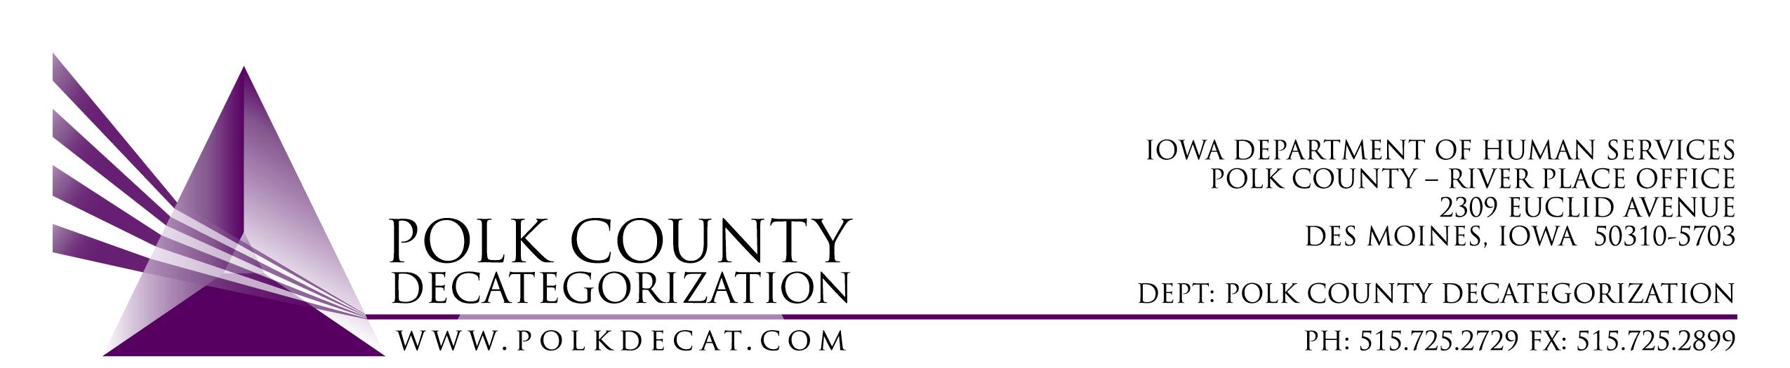

POLK DECAT EXECUTIVE COMMITTEE
Thursday, April 9, 2020
10:00 am – 12:00 pm
Video Conference

MEETING A G E N D A

- Call to order: Time _________ | Eric Kool
- Review and approval of the March 12, 2020, meeting minutes *  1st_________ 2nd __________ Approve: Y/N | All
- Review of FY21 budget, plus Decat and RJCE budgets | Teresa
- Discuss and vote: Add $12,877 of MYFI funds and $5,500.00 of JCS State funds to the RJCE Coordination Services contract (DCAT5-17-052), changing contract from $134,226.00 to $152,603.00, and approve the amendment for the change.*  1st_________ 2nd __________ Approve: Y/N | Teresa, Jana & Christy
- Discuss and vote: Accept Evaluation Committee recommendation for new Refugee Immigrant Guide Coordination Services contract successful bidder, and approve the contract.*  1st_________ 2nd __________ Approve: Y/N | Teresa
- Discuss and vote: FY21 renewals – refer to Executive Committee Agenda Addendum for 04/09/2020.* | Teresa
- Updates:  - Work from home status  - RJCE and CPPC activities | Teresa
- Next meeting:  - FY21 CPPC Plan and Budget  - Review of FY20 budgets  - ICAPP grant  - MIHF Grants  - RJCE and CPPC activities  - Anything else? | All
- Adjourn: Time ___________*  1st_________ 2nd __________ Approve: Y/N | Eric Kool

Next meeting: May 14, 2020, 10:00 am, Polk County River Place, Conference Room 3 or via video conference depending on “stay in place” status.

