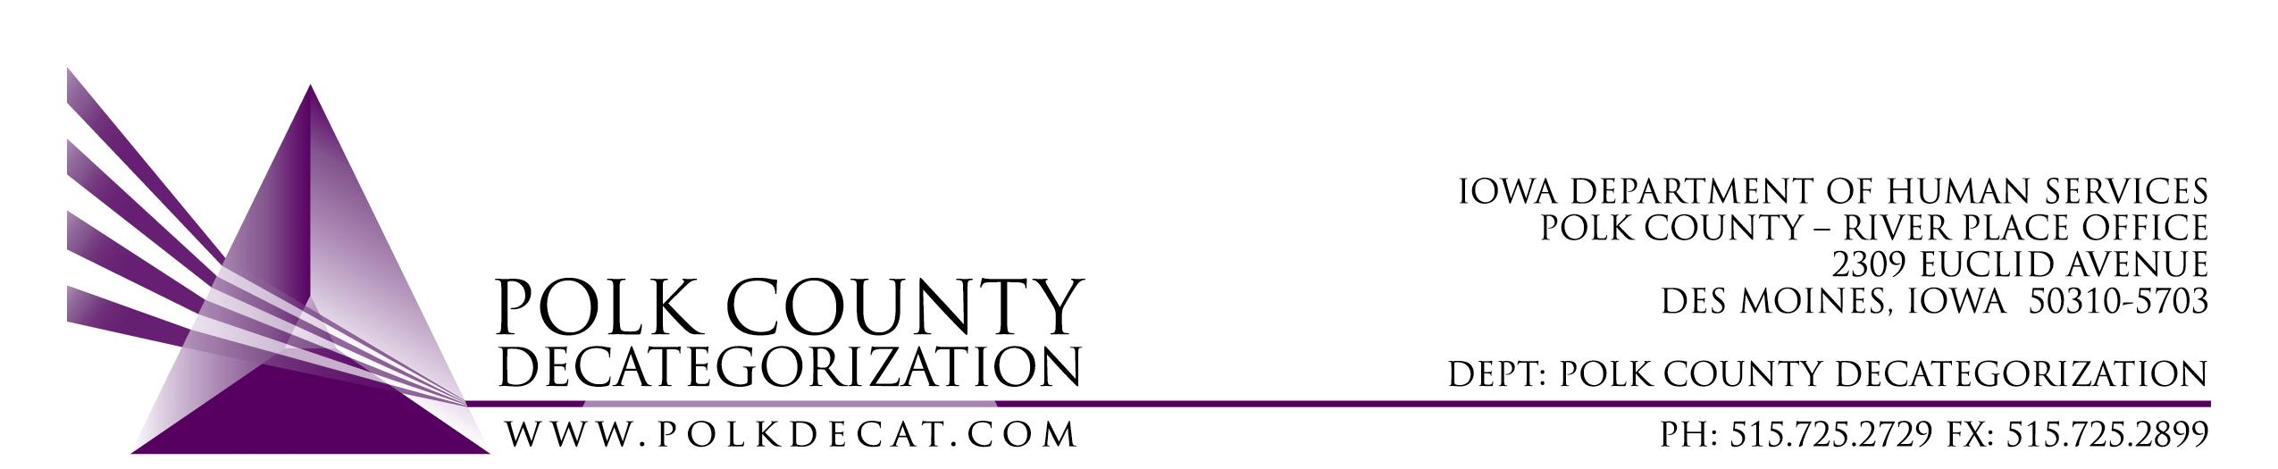

DECAT EXECUTIVE COMMITTEE
Thursday, March 8, 2018
10:00 – 11:30 am
Polk County River Place, Conference Room 3

MEETING A G E N D A

- Call to order & welcome new Steering Committee Representative | Mike
- Welcome Diamond Denney, New Restorative Justice Cultural Equity Coordinator | Teresa
- Review and approval of January 11, 2018, meeting minutes*  1st_________ 2nd __________ Approve: Y/N | All
- Discussion and vote: Approval of CPPC Shared Decision Making Team vote for Youth Emergency Services & Shelter to serve as the Polk CPPC Designated Agency to bid on Polk ICAPP funds for Emergency Respite for non-system youth.*  1st_________ 2nd __________ Approve: Y/N | Teresa
- Swap PSSF funds for DHS state funds in DCAT5-13-184, Fiscal Agent Services contract.*  1st_________ 2nd __________ Approve: Y/N | Teresa
- Review of FY18 & projected FY19 budget | All
- Increase funding levels for contracts projected to be short*  Contract___________________________________  Amount Increased___________________________  1st_________ 2nd __________ Approve: Y/N  Contract___________________________________  Amount Increased___________________________  1st_________ 2nd __________ Approve: Y/N | Teresa
- Renewal Discussion & Voting* | All
- Updates:  - RFP/RFB status  - Decat/CPPC and RJCE Budget – Waiting for information from PCHS | Teresa
- Next meeting:  - Contract Renewals  - RFP/RFB Evaluation results and voting on Successful Bidders  - Budget review  - Anything else? | All
- Adjourn  1st_________ 2nd __________ Approve: Y/N | Mike

Next meeting: April 12, 2018, 10:00 am, Polk County River Place, Conference Room 3

