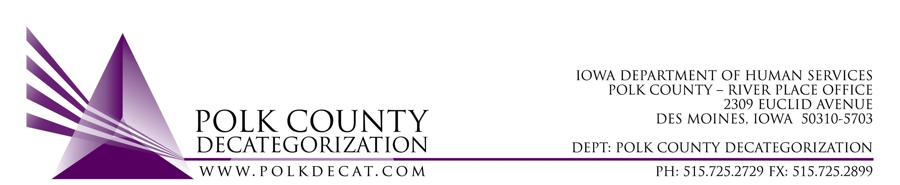

DECAT EXECUTIVE COMMITTEE
Thursday, February 14, 2019
10:00 – 11:30 am
Polk County River Place, Conference Room 3

MEETING A G E N D A

- Call to order: Time _________ & welcome Stephanie Swartz, new Steering Committee representative and Angela Crees, new DHS EO1 | Chad
- Review and approval of the December 13, 2018, meeting minutes*  1st_________ 2nd __________ Approve: Y/N | All
- FY19 Budget review and projection for FY20 | Teresa
- Review proposed budgets for DCAT5-18-002, Decat & CPPC Coordination, and DCAT5-17-052, RJCE Coordination for FY20 | All
- Discussion and vote: Review & accept DCAT5-19-036, JCS Internal Climate Survey Evaluation Committee recommendations for Contractor.*  1st_________ 2nd __________ Approve: Y/N | All
- Discussion and vote: Approve new contract for DHS Criminal Records Checks, Polk County Attorneys’ Office, to be effective July 1, 2019.*  1st_________ 2nd __________ Approve: Y/N  Annual Contract Value: $__________________ | Teresa
- Discussion and vote: Approve new contract for DHS Diversion and Mediation Services, Polk County Attorneys’ Office, to be effective July 1, 2019*  1st_________ 2nd __________ Approve: Y/N  Annual Contract Value: $__________________ | All
- Contract review for renewals for FY20 | Teresa
- Decat Updates:  - RJCE Updates  - Decat/CPPC Updates | Teresa
- Next meeting:  - Quarterly report review  - Vote on contract renewals for FY20  - Anything else? | All
- Adjourn: Time ___________  1st_________ 2nd __________ Approve: Y/N | Chad

Next meeting: March 14, 2019, 10:00 am, Polk County River Place, Conference Room 3

