We’re opening doors across the state!  Tuesday March, 27, 2018  CPPC 2018 sPRING  STATEWIDE LEARNING NETWORK  Keynote speaker, Dr. Jennifer Harvey will share her recently released book Raising White Kids: Bringing Up Children in a Racially Unjust America; written for communities who want to equip children to be active and able participants in a society that is becoming one of the most racially diverse in the world while remaining full of racial tensions. Attendees will receive a complimentary copy of the book and Dr. Harvey will be available for book signings.  A morning panel discussion on refugee and immigrant resource information and personal experiences in Iowa will be followed by afternoon workshops on contemporary topics of interest to CPPC community partners.  Coffee and registration at 9am  Programming begins at 9:30am and concludes at 4pm  Watch your email for your invitation/registration via Eventbrite  Light breakfast, lunch, and snacks will be provided  Contact Jolene Holden at jholdenx3@yahoo.com with questions. | Keynote Speaker  Dr. Jennifer Harvey  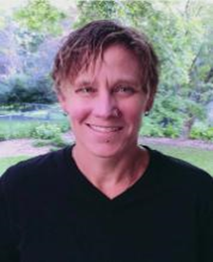  ────  Interactive Panel Discussion  ────  Exciting Workshops  ────  Provider Networking  ────  