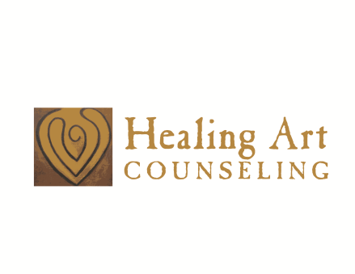
Women’s Circle-Creative Expressions Group
When: Thursdays 6:30 - 8:00 pm October 26th- November 16th 2017
Where: At Healing Art (7644 Hickman road, Windsor Heights, IA)
Would you like to: Reconnect with your creativity? . . . Access your intuition? . . . .
Take a relaxing break from everyday stress? . . . Renew your spiritual connection? . .
Learn new way to become more at peace and in the moment? . . .
Expand through your inner wisdom? . . .
If you answered yes to any of these questions then contact Radmila, MA, LMHC, ATR-at:
rabram@healingartcounseling.com www.healingartcounseling.com or 515-276-5475, to
to find out more about this group and preregister.
Art materials will be provided. $80 for four sessions, must preregister
No previous artistic skills needed!

Art for Peace Group
When: Every first Monday of the month 6:30pm -8:00pm.
At Healing Art (7644 Hickman road, Windsor Heights, IA)
Bring your own art materials.
Basic art materials will be also available for use. Free will donation
No previous artistic skills needed!
We will engage in the creative process as a way to support each other through images and words of compassion and encouragement.
Both groups: Space is limited to seven participants! Preregistration is required.

